Group id : A6

Project Name : Stock Candle

**Assignment 11**

Title: Prepare Class Model

Problem Statement: Identify Analysis Classes and assign responsibilities. Prepare Data

Dictionary. Draw Analysis class Model using UML2.0 Notations.

Theory :

Class Diagram

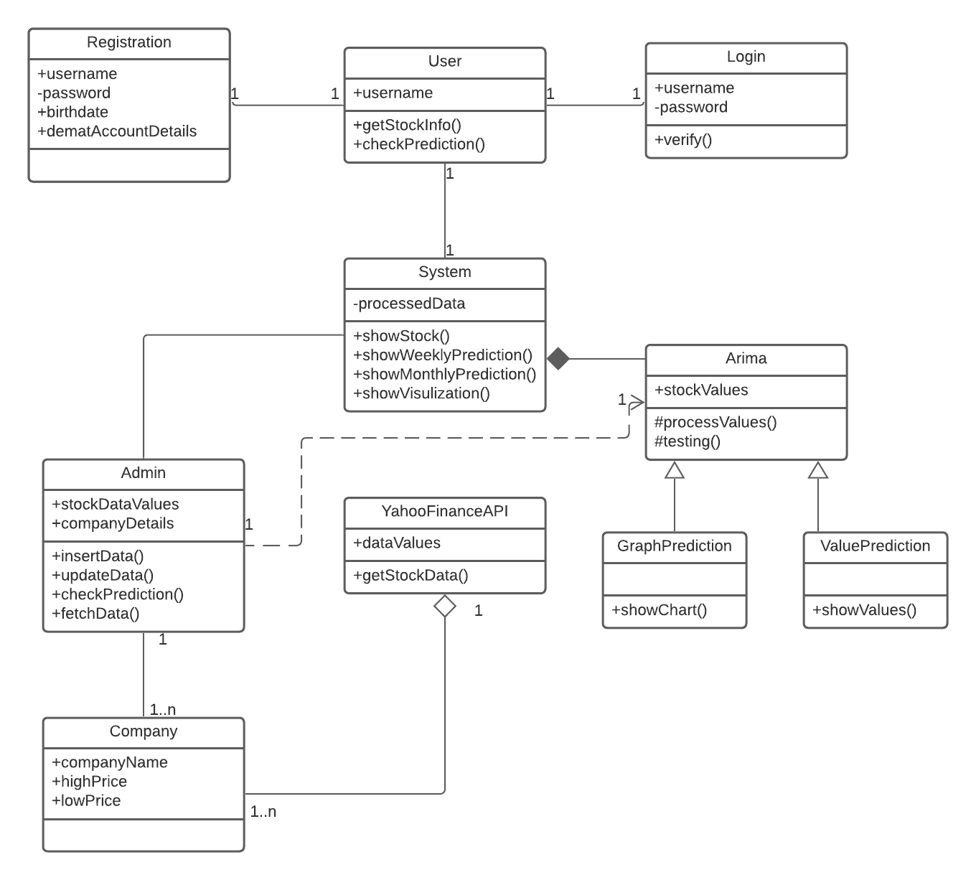

**Conclusion :** Thus, we have prepared uml class diagram using advanced uml2 notations and lucid chart.